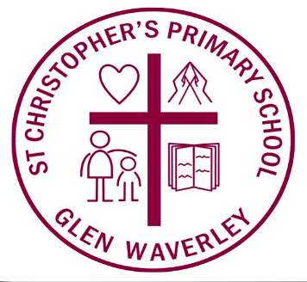


Photography and Recording Permission Form

As set out in Melbourne Archdiocese Catholic School Ltd (MACS) Privacy Collection Notice – Students and Parents (Collection Notice), MACS/the school will seek consent from the student’s parents and carers and from the student if appropriate.
This form relates to consent to be obtained in cases of specific external use of publications.
This form is provided to seek consent for the collection and use of photographs and recordings for specific purposes as set out below. Consent may be varied subsequent to returning this form if you change your mind. The principal will remind parents and carers annually of this option to vary through the school’s usual communication channels. A new consent form will need to be completed to give effect to a change or withdrawal of permissions.
If you consent, MACS/the school may use the photographs or recordings in the ways listed below:
- General media and promotional material including:
  - school magazines
  - news stories
  - pamphlets
  - advertising
  - promotional material
- Other public use on either the school’s or MACS’:
  - newsletters and other similar communications to the school community and public
  - websites
  - social media accounts
- National Educational Access Licence for Schools (NEALS): The photographs and recordings may also appear in material which will be available to schools and education departments around Australia under the NEALS. This is a licence between education departments of the various states and territories, allowing schools to use licensed material wholly and freely for educational purposes.

Parents will be notified and specific consent will be sought independently of this Authorisation should/if MACS or the school wish to use any images of students in mass market news media or advertising campaigns.

Authorisation
Please ensure you have read the form carefully and contact the school if you do not understand any aspect of it.

☐ | - I agree and permit MACS and its nominees to use photographs and recordings (Material) including without limitation reproducing, exhibiting, editing, adapting, compiling with other works or materials, transmitting, broadcasting, publishing and distributing the Material in any media as set out in this Photography and Recording Permission Form.  - I give permission for photographs and recordings of me/my child to be used by the school or MACS as set out in this Authorisation in the agreed publications without acknowledgement, remuneration or compensation.  - I understand and agree that it is my responsibility to notify the school if I wish to withdraw this Authorisation and consent.
☐ | I do not agree to the school or MACS and its nominees to use any Material that includes me/my child in any publication set out in this Photography and Recording Permission Form.

Student and Family Details

Student name(s) |  |  | Year level

Parent or Carer details
Parent 1/Carer 1 Name
Signature |  | Date
Parent 2/Carer 2 Name
Signature |  | Date

